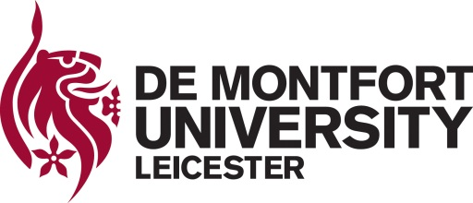

De Montfort University – eParasitology Learning resources for the Study of Parasites
Take-Down Procedure
The University has endeavoured to ensure that no material deposited in eParasitology infringes any third party property rights or otherwise infringes UK law. However, should you discover any content in eParasitology that you believe infringes your rights, please notify Dr Antonio Peña Fernández (DMU eParasitology project lead) at Antonio.pena-fernandez@dmu.ac.uk , specifying the particular item(s) that is subject of your complaint and the particular grounds for your complaint. These grounds may include:
- Proven copyright violation or plagiarism.
- Legal requirements.
- Falsified research.
If you wish to issue a complaint regarding items available from eParasitology, please include the following information in your notice and send it to Antonio.pena-fernandez@dmu.ac.uk
- Your full contact details
2. Bibliographic details for the item, including a URL of the record
3. An outline of the nature of the complaint.

On receipt of a complaint we will:
- Make an initial judgement on the validity of the complaint.
- Withdraw the item in question from public view.
- Return an acknowledgement that the complaint has been received.
- We will advise the person who deposited the resource in question, outline the nature of the complaint and give them the opportunity to refute the complaint.
- We will investigate the complaint in full, obtaining advice as required, and contact the complainant and the depositor with the result of this investigation and what action we have taken/will take;
- If the grounds of the complaint are considered plausible, the material will be removed permanently unless the complainant gives us permission to retain it. If we are required to remove the material permanently, we will retain the metadata to avoid loss of historical record together with a note explaining the reasons for the withdrawal.

